Using Multimedia to Enhance a Web Site (Tourist Bureau Project)
Examples of Various Types of Tourist Bureau web sites:
http://www.egypttourism.org
http://www.australia.com/
http://www.visitbritain.com/en/US/
http://www.enit.it/

How Can We Use Video &/or Animation to Enhance a Website?
When deciding to use video &/or animation to enhance your website, you need to plan 1st:

- Why do you want to use video or animation?
- What purpose will it serve & how will it help you achieve the goal of your web site?
- What do you want to include in your video or animation to maximize this multimedia tool?
Planning your multimedia “story” using a StoryBoard:
A storyboard is a detailed planning “map” specifically organizing what media you intend to use and how you intend to use the various media together to create a story that is well designed and achieves your goals. In the case of this project, your goal is to:
- Capture the attention of your audience and
- Convince them that the location that you have research is a place they want to visit.
There are many different storyboard templates available to use to help you organize your ideas before you get started creating your multimedia production. Examples of templates you can use are available at:
http://gaildarmody.weebly.com/web-design-projects.html
http://storykeepers.wikispaces.com/StoryBoarding

When you think your storyboard is complete and you are ready to start production, click here to make sure:
https://sps-newmedialiteracies.wikispaces.com/file/view/Analytical-StoryBoarding-Checklist1.pdf

Creating & Using Animation Using Free Online Tools to Enhance a Web Site:
Moovly.com:
http://www.moovly.com/
GoAnimate:
http://goanimate.com/
Wideo:
http://wideo.co/
Voki:
http://www.voki.com/

Examples of animation projects from other schools:
http://www.lee.k12.nc.us/Page/7060
Find more interactive tools to enhance your website on my Web Design Resources Hotlist at:
http://www.kn.att.com/wired/fil/pages/listwebdesimr1.html (which is also linked to our class website)

Uploading Videos to YouTube (http://www.youtube.com/) :
- Can upload video from a file you have saved to a USB storage device, or directly from your Smartphone using the free YouTube app for Android or Apple
- Can perform simple editing using YouTube video editing tools & embed or link video
- Supported File Formats include: .MOV, .MPEG4, .AVI, .WMV, .FLV & more!
Uploading Video Files to Pixorial (http://www.pixorial.com/) :
- Can upload video you have saved to a USB storage device or directly from your Smartphone using the free Pixorial app for Android or Apple. You can also upload directly from your WebCam.
- Can perform simple editing using Pixorial video editing tools & embed, link or share video
- Supported File Formats include: .AVI, .FLV, .MOV, .MP4, .MPEG, .MPG, .DV, .WMV

- Once you have created a video, uploaded it to YouTube or Pixorial and edited it, you can then embed the video, using the HTML code, or link to your video within your website to capture the attention of your audience!
Editing video with YouTube Video Editor
The Video Editor is a free tool on YouTube that allows you to edit your own uploaded clips and others to produce an entirely new video. With the Video Editor, you can:

- Combine multiple videos and images you’ve uploaded to create a new longer video
- Trim your uploads to custom lengths
- Add a soundtrack from our library of approved tracks
- Customize clips with special tools and effects

To access the Video Editor, just go to http://www.youtube.com/editor or follow these steps:
- Log in to your YouTube account.
- Click on the arrow next to Upload at the top of any YouTube page.
- In the menu that appears, click Video Manager.
- Click Video Editor at the top of the page

1. Adding Clips
- Any of your uploads (videos or images) used in the Video Editor is a clip. Your new video can be made up of various clips (up to 50).
- You'll see an area in the top left section of the page. This is called the Media Picker, and it's where you'll find all the clips and enhancements you can add to your video.
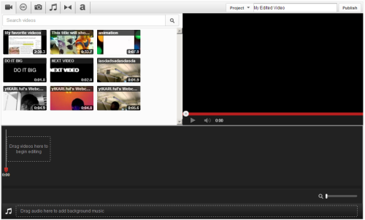
- In the Media Picker, select the clip(s) which you’d like to edit. You can choose from your own uploads, a selection of pre-approved Creative Commons licensed videos, and your own images from your Google account or images you upload from your computer.
- Click the plus icon (+) on the upper right side of the clip. This will add the clip to the area below known as the Timeline (you can also drag and drop the clip down to the storyboard timeline).
- Once you’ve added your video clips or images to the storyboard, you’ll be ready to edit the video clips

2. Trimming Clips
- As you're creating your new video, you'll likely want to shorten the clips you're using. Trimming a clip is simple. To start, click on the name of the clip you want to edit in the Timeline.
- You'll now see two bars with horizontal lines on them appear to the left and right of each clip. These bars represent the beginning and end of your video.
To shorten a clip, drag the left or right bar to the other side.
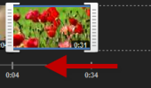
- After a clip has been shortened, it can be lengthened by dragging a bar to either the left or right. As you trim and extend your clips, you'll see the duration of each clip get longer or shorter.

3. Customize Clips
The Video Editor gives you the tools to add tweaks and enhancements to your clips. You can:
- Rotate clips
- Add effects like brightness levels and stabilization
- Add text
To access any of these features, just move your cursor over the center of the clip in the storyboard. You'll see three buttons appear:
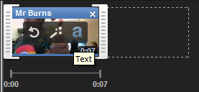
Click on the circular arrow to Rotate, the magic wand to add Effects, and the lower case "a" to add Text.

Rotating: You can Rotate a clip so it orients at a left or right angle. Click on a clip in a timeline, select the Rotate tool, then choose left or right.

Effects: Use Effects to customize and improve the look of your clip.

- I'm Feeling Lucky automatically chooses the ideal brightness and contrast configuration for your clip. If you want your clip looking its best but don't want to worry about changing settings, pick this.
- Brightness and Contrast allows you to tweak the lighting in your clip to your preference. Move the sliders to your preference and see the results in the preview above.
- Black and White turns your clip black and white, if you're aiming for a classic look.
- Stabilize Video automatically detects camera shakiness and tries to remove these from your clip to make it look smoother.

Text: Text can be added as an overlay on your video. You can customize the size and color of your text. All effects also work on images.

4. Adding an audio track
You can add a new audio track to your video in using the YouTube Video Editor. Here's how:
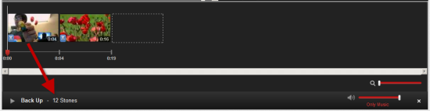
- In the Media Picker, click the Audio tab that looks like a music note. You’ll then see audio options appear. These audio tracks come from YouTube’s library of pre-approved songs.
- You can browse the library of tracks by genre and artist, and also by typing a query into the search bar.
- To preview the listed audio-tracks, hover your mouse over the an audio-track in question and click the 'Play' button. A preview will then play for you.
- To add an audio track to your clips, click the 'plus' icon (+) on the audio-track. This will add the audio track to the timeline. You can also drag and drop the audio track into the audio section below the timeline.
You cannot trim or edit the audio track in Editor. The audio track will stop when the track ends. You also cannot select particular sections of the audio track: the audio will start at the beginning and will be cut-off when the video ends.
To delete the audio track entirely, just click the 'X' icon on the audio track in the timeline. You can also replace the audio track by dragging another track from the media picker down to the storyboard. The existing track will immediately be replaced with the new track.
The audio from an added track will overlap replace your clips’ original audio by default. To customize the volume at which an audio track plays over your clips, adjust the volume slider to at the far right of the name of the track. You can choose between:
- Only Music (the default): Plays only the added audio track.
- Favor Music: Plays the swapped in track most prominently.
- Equal: Plays original and swapped audio at equal volume.
- Favor Original Audio Plays the original audio from your clips most prominently.

5. Publishing Your Project
As a final step, click Publish. Your video will then be saved and can be shared.

Editing video with Pixorial
Movie Creator is our easy-to-use video editing tool that allows you to trim videos, combine clips from different videos, add music, and create text, titles and credits. We've provided a quick overview, followed by detailed instructions on all of Movie Creator's features.

QUICK OVERVIEW
1. Log in to your Pixorial account.
2. Click the ”Create Movie”button at the top of your screen.
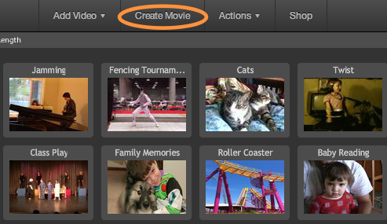
Once Movie Creator opens, you can either select a previous production or simply start a new production by selecting “Create New.”
3. Add your first video clip by selecting the “+” button and then “Video.” Work your way across the timeline adding more items by clicking the“+” buttons at the spot you would like to add them. Note that you can reorder the items in the storyboard by simply dragging them to a different position.
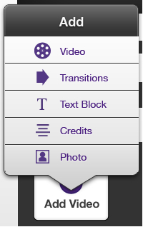
Click the “Play” button (the large triangle shaped button) to view what you’ve done.
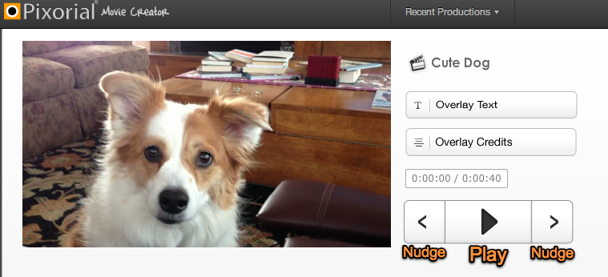
4. Save your work by clicking the “Save” button. You can leave Movie Creator by clicking on “Return to Library” and come back later to do more editing. Movies you’re still working on will show up in your Library with a grey “In Production” thumbnail.
When you’re satisfied with your work, open your video in Movie Creator and select “Finalize Movie.” Your video will be rendered into your Pixorial Library, which can take some time depending on file size and server loads. In the meantime, your video will have a grey “Processing” icon.
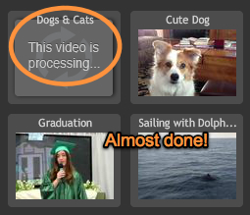
When your video is done, a thumbnail will appear. Your video is now ready!
Didn't catch all that? Don't worry -- we lay out all the details below. Just keep reading!

MOVIE CREATOR: EVERYTHING YOU NEED TO KNOW

Adding Video:
- Click on a “+” button in the storyboard where you would like your video to appear.
- When the menu pops up, select “Video.” A window will open up that has the same organization we use in your Pixorial Library. You can click on a folder name to locate the videos in that folder.
- Select the video or videos you would like to add and click the“Add” button. Click “Add All” if you would like to include all the videos in this view.
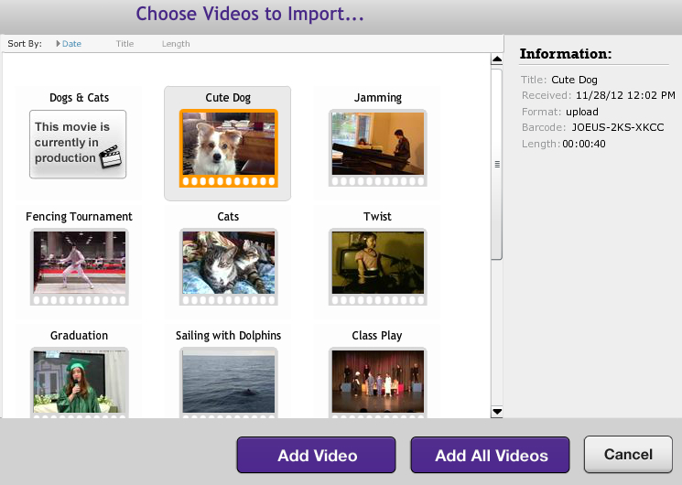
Click "Add Video" to add selected video or videos. "Add All Videos" will add every video in your Pixorial Library.
Reorder the videos in the storyboard by simply dragging them to a different position.
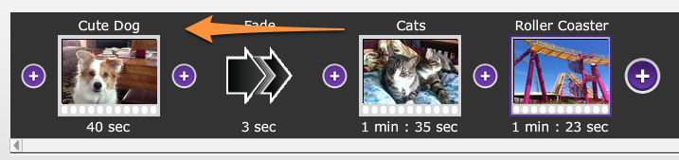
Drag items to change their position
- Click the “Edit” button that appears when you move your cursor over a video if you would like to trim the beginning or ending of the video.
- When the trim window opens, drag the left and/or right trimmers (the gold icons on each end of the video timeline) to establish the start and end points.
- You also have the option to rotate the video if needed. This is useful when working with video taken with a smartphone. NOTE: Trims made in Movie Creator do not permanently alter your original videos, and you can re-use an original video in as many Movie Creator Productions as you like.
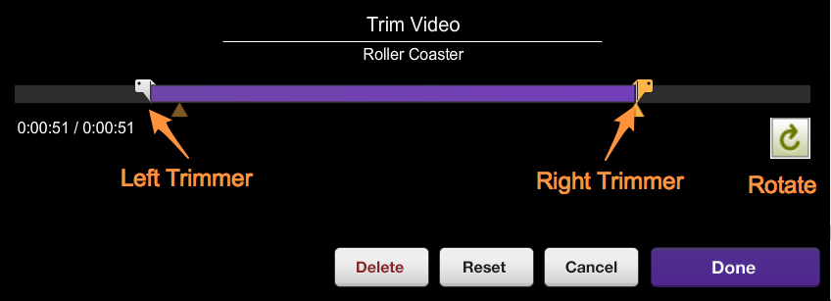
Drag the left and/or right trimmers to establish the start and end points

Adding Photos:
- Click on a “+” button in the storyboard where you would like a photo to appear.
- When the menu pops up, select “Photo.” A window will open up that will allow you to Upload a photo from your computer or Add a selected photo.
- If you have not uploaded any photos yet, click the “Upload” button to find a photo you would like to add to your production.
- Once you have photos added, locate the photo you would like to add and click the “Add” button to add the photo to the Storyboard.
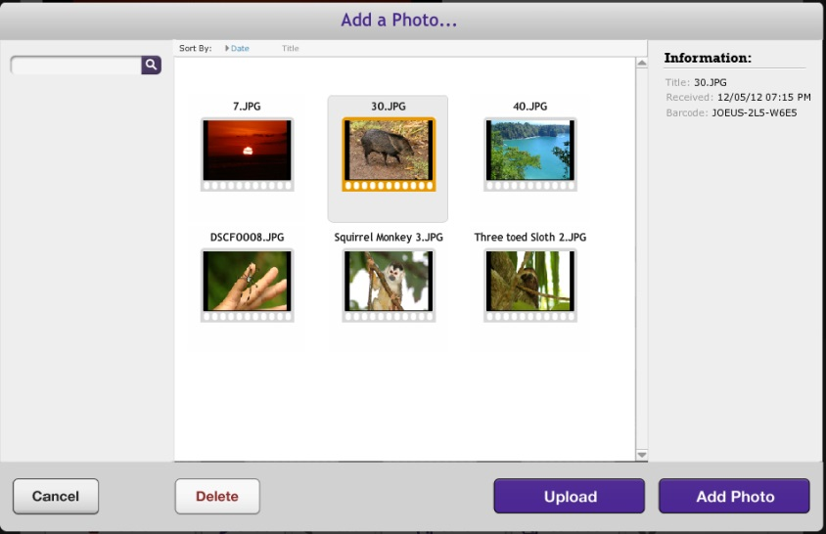
Select a photo or Upload a new photo
- Reorder the photos in the storyboard by simply dragging them to a different position.
- Click the “Edit” button that appears when you move your cursor over a photo if you would like to change the duration (the amount of time the photo will appear), scale the photo larger or smaller, rotate the photo, or drag the photo to a different position within the window.
- From the Edit window, you can also Delete the photo or select Reset if you would like to reset the duration or rotation.
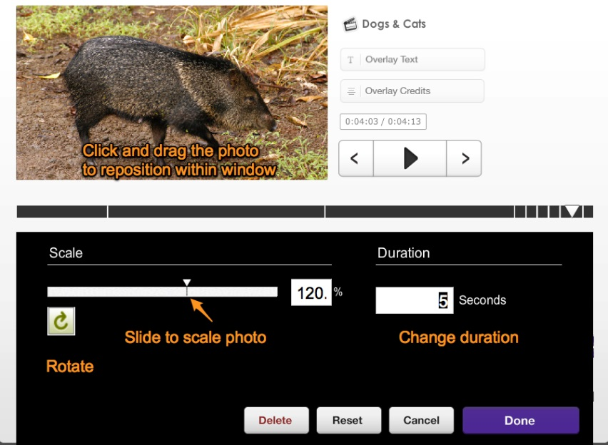

Adding a Transition:
- Click a “+” button where you would like to place a transition. When the menu pops up, select from one of the available transitions. You can use a “Fade” transition at the beginning or ending of a production in order to fade into or out of your video.
- Once a transition is added, you can double-click on it or click the Edit button to change the length of the transition.
- Click on the transition and press the Play button to see how it looks when playing. This is a quick way to check your transitions.
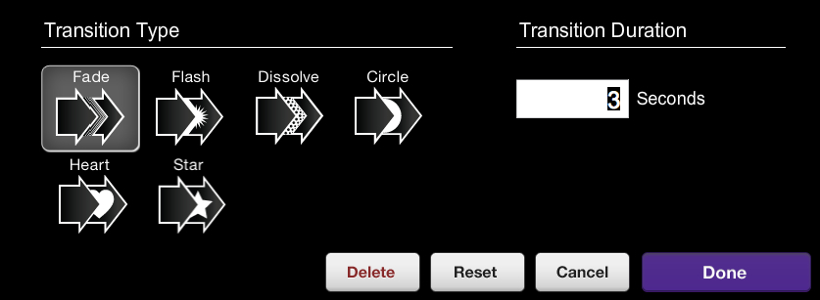

Adding Title Blocks:
- Click on a “+” button in the storyboard where you would like to add a title. When the menu pops up, select“Titles.” Note that these title blocks will appear between your videos and/or transitions. We’ll cover how to “Overlay” text on top of your video later in these instructions.
- Once a title is placed in the storyboard, it will switch to a view that allows you to pick a font, adjust the size, the style, alignment, color, and duration of the title.
- You can move the title to any position you like within the video window with a simple click and drag.
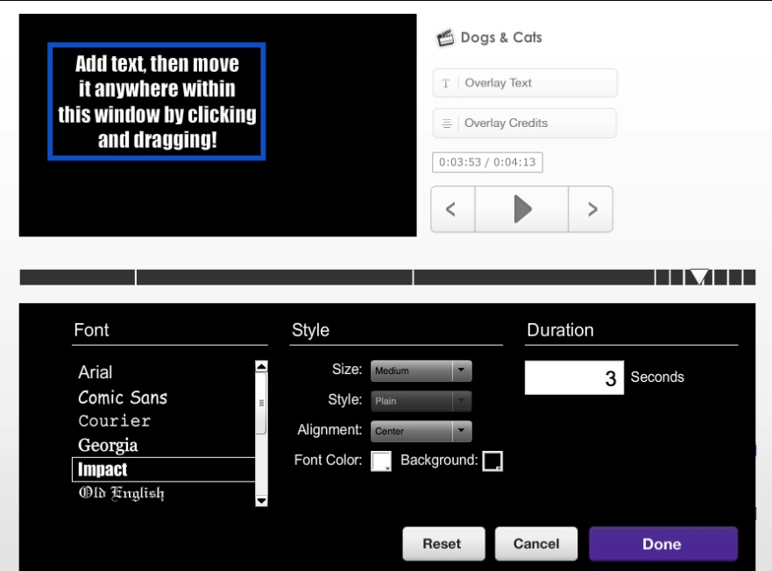
- Click the “Done” button when you’re happy with the title placement and look.
- If you would like to make changes to the title, you can either double-click on the title block in the storyboard, or click on the title and click the “Edit” button.

Adding Credits:
- Click on a “+” button in the storyboard where you would like to add your scrolling credits. When the menu pops up, select “Credits.” Note that these credit blocks will not playback over your video. We’ll cover how to “Overlay” credits on top of your video later in these instructions.
- Once a credit is placed in the storyboard, it will switch to a view that allows you to pick a font, adjust the size, the style, alignment, color, and duration of the credits.
- You can move the credits left or right on the screen to position them by simply clicking and dragging the credit text field.
- Click the “Done” button when you’re happy with the placement and look of the credits.
- Click on the select the credit icon and click the “Play” button to check the playback speed of the credits.
- If you would like to make changes to the credits, you can either double‐click on the credit block in the storyboard, or click on the credit icon and click the “Edit”button.
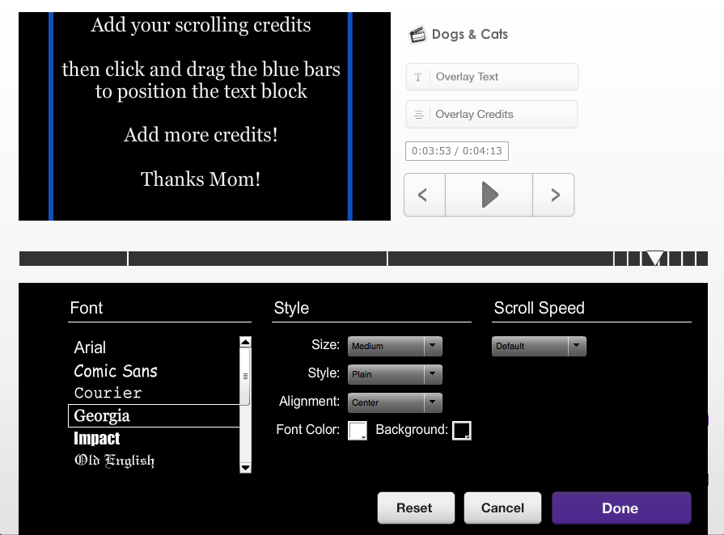

Adding Overlay Text:
- Click on the “Overlay Text”button that is next to the video preview window.
- Once the Overlay Text button is selected, sample text will appear over the video and the Storyboard will change to a view that allows you to pick a font, adjust the size, the style, alignment, color, and duration of the title.
- You can move the text to any position you like within the video window with a simple click and drag.
- Click the “Done” button when you’re happy with the overlay text placement and look.
- If you would like to make changes to the text, you can either double‐click on the text indicator that is above the timeline, or move the playback head to where the text is located, then click on the overlay text to toggle to edit mode. Click “Done” when you are happy with your updates.
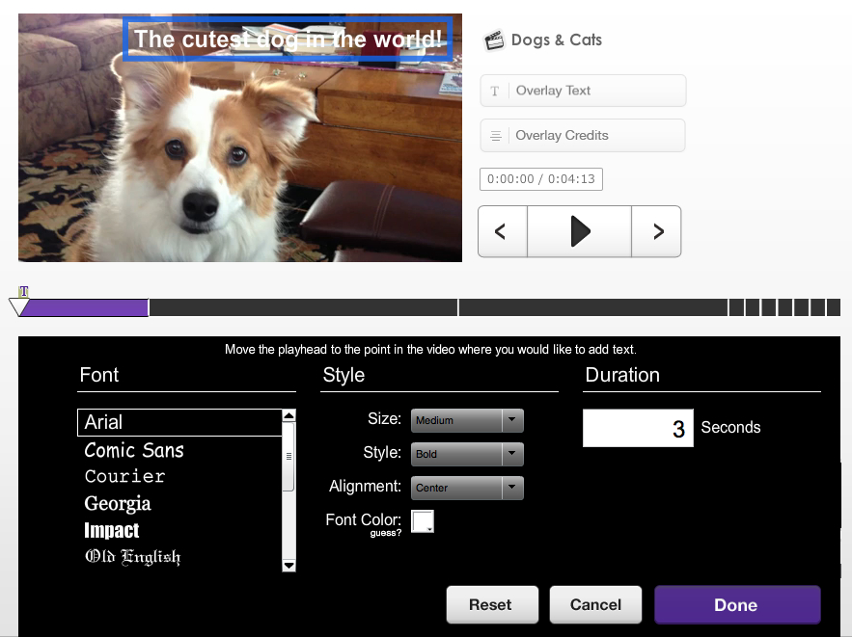

Adding Overlay Credits:
- Click on the “Overlay Credits”button that is next to the video preview window.
- Once the Overlay Credits button is selected, sample text will appear over the video and the Storyboard will change to a view that allows you to pick a font, adjust the size, the style, alignment, color, and duration of the title.
- You can slide the text credit text field side to side within the video window with a simple click and drag.
- Click the “Done” button when you’re happy with the overlay credits placement and look.
- If you would like to make changes to the text, you can either double‐click on the overlay credits indicator that is above the timeline, or move the playback head to where the credit text is located, then click on the credit text to toggle to edit mode. Click “Done” when you are happy with your updates.
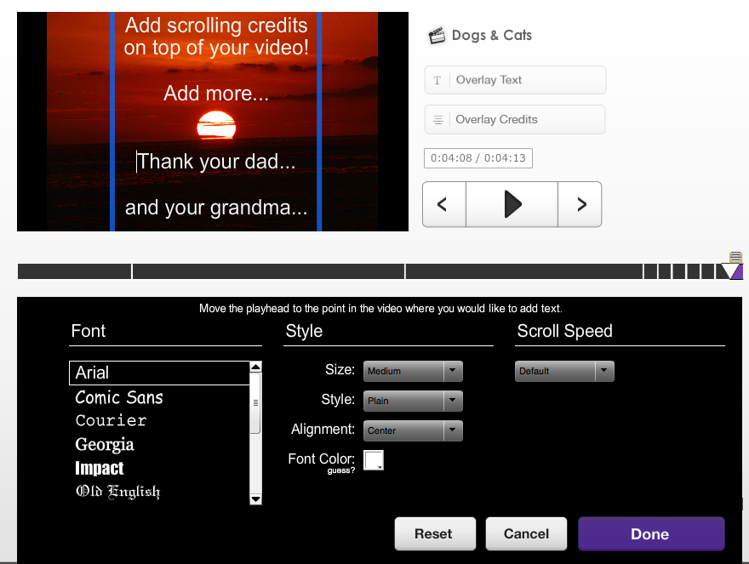

Adding a Music Track:
Move the playback head (the green diamond) to the point where you would like the music track to start. Click “Add Song” to choose from hundreds of music tracks provided by Pixorial, or click the “Upload” button to add your own song.

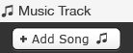

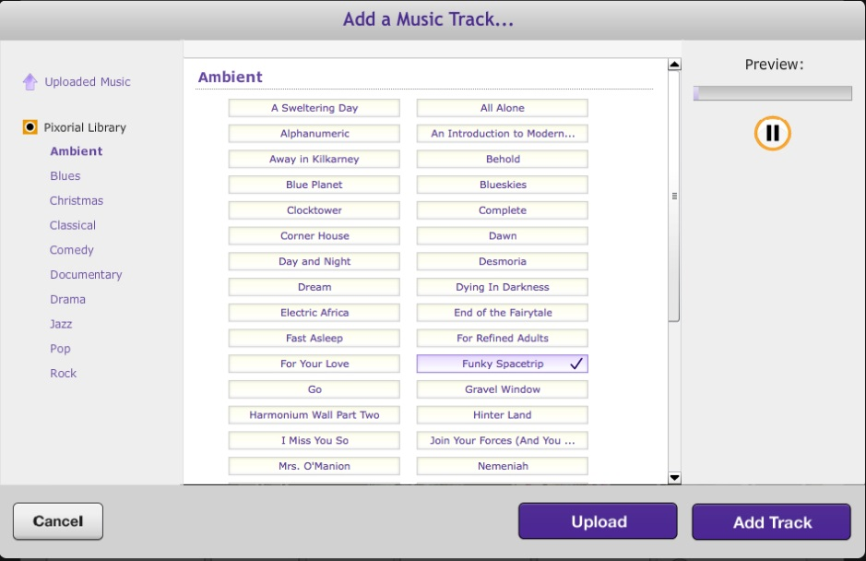
- Once a music track is added and selected, by clicking on the track, information and options will be presented below the track.
- You can Replace or Delete a track, adjust the Start Offset (where the song will start if you do not want it to start from the beginning of the song), or you can adjust the Duration of the song.
- To change the Start Offset or the Duration, simply move your cursor over the time that is indicated then click and hold down the mouse or trackpad button. The cursor will change to a double arrow pointing left and right. Once you see the double arrow, move the cursor to the left or right to change the time.
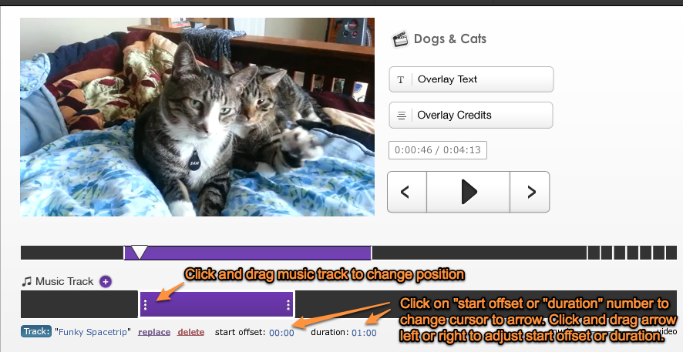
If you would like to change the position of the music track (if there is room) simply click and drag it to a new position.

Save and Share:
Once you finish your production, click the “Save” button and give it a name, if you have not done so already.
- Click Save, name your video, then click Add to Library when you are ready to share the video. After you save, the“Finalize Movie” button will be available.
- Clicking the “Finalize Movie” button will close Movie Creator and bring you back to the Library where you’ll see that your video is being processed.
- Note that you can go ahead and share your video without waiting for it to be completely processed. The video will continue to process on Pixorial’s servers, then will be delivered or posted as soon as it is ready.

