Introduction to Glogster for Education - http://edu.glogster.com/
- Once you are on the Glogster for Education website, scroll down the page until you reach the “Single Free” section and click on the REGISTER HERE button to setup a free account.
- Once your account has been successfully created, you will be brought to My Dashboard.
- From this screen, click on the CREATE NEW GLOG button to begin creating your multimedia poster.
- This tool is ideal to create a digital multimedia poster, brief newsletter and more!
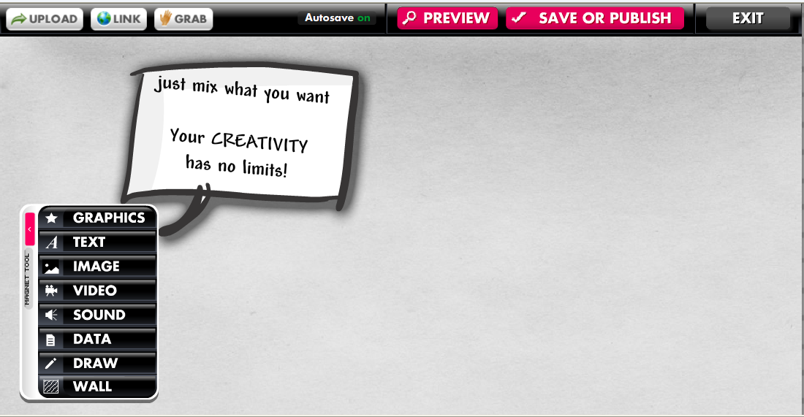
  - Wall – enables you to select a background for your glog
  - Graphics – enables you to select a digital clip art image within Glogster to insert into your glog. You can edit the color of the image, add effects & link the image to a website.
  - Text – enables you to type text within a preformatted textbox. You can edit the text size/font & drag the text box to change the size etc.
  - Image – allows you to upload your own digital image file to the glog tool & use a frame image as well.
  - Video – allows you to upload your own short video clip (100 MB limit) or search for a video to upload. Choose a Player to nicely frame your video clip in your glog.
  - Sound – allows you to upload or create your own audio to include in your glog.
  - Data – allows you to upload your own digital file to link to your glog.
  - Draw – allows you to create a free-hand drawing to include in your glog.

- While in Edit mode, the link tool allows you to link almost any object/image in your glog to another website.

- Don’t forget to save your work with a file name by clicking on the SAVE OR PUBLISH button. Then select either Unfinished or Finished (do not select public) & click SAVE.
- Share your glog by copy/pasting the embedded code to post in a website or blog (you can email it too)

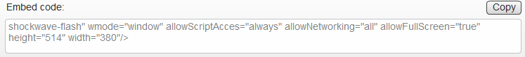

*Note: There is no limit to the file size. These are the file types that Glogster supports:
Upload file types:
audio: .aac, .aiff, .m4a, .mp1, .mp2, .mp3, .ogg, .raw, .wav, .wma
video: .asf, .avi, .m2v, .mpeg, .mpg, .nsv, .wmv, .mp4, .flv, .mov, .m4v
image: .jpg, .jpe, .jpeg, .bmp, .gif, .tif, .tiff, .png, .pcx, .wmf, .tga,.psd, .crw, .cr2, .nef, .orf, .raf, .dng,
.mrw, .pef
Link file types:
audio: mp3
video: flv (+youtube url)
image: .jpg, .png, .bmp, .gif
The Glogster EDU user guide is available to view and/or download here:
http://edu.glogster.com/download/glogster-edu-users-guide.pdf

Other instructional resources for using Glogster:
http://www.youtube.com/watch?v=p0HmWdsrFsU

Exemplars of Glogs:
http://judylambert.edu.glogster.com/21st-century-skills/
http://kcampbell34.edu.glogster.com/why-use-glogster/
http://nath13.edu.glogster.com/edukit/
http://welrod.edu.glogster.com/career-glogging/
http://morgiwanna.edu.glogster.com/educational-use-of-the-ipad-and-itouch/
http://liebermanc.edu.glogster.com/glog-9993-8940/
http://blessedteacher.edu.glogster.com/review-of-online-presentations/
http://amarkus.edu.glogster.com/voice-thread/
http://azharyoussef.edu.glogster.com/moodle/
http://zprine.edu.glogster.com/glog-7531/

