How to Take a Screenshot using Chromebooks and the Chrome OS
(from http://www.makeuseof.com/tag/taking-screenshots-chromebook/)

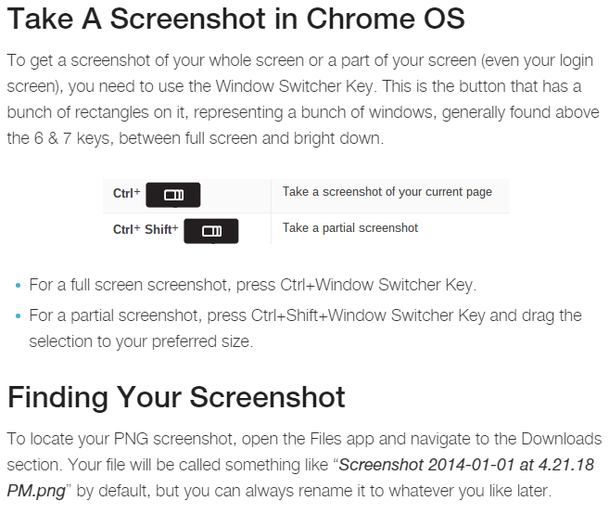
To insert your screenshot into your Google Doc:
- Open the Google Doc
- Click on “Insert” from the horizontal menu
- Select “Image” and “Uploads”
- Select the appropriate .PNG file to insert into your Google Doc

